**PyBank Starter**

**Explanation:**

1. **Import Libraries:**
   * csv: For reading and processing the CSV file.
   * os: For handling file paths.
2. **File Paths:**
   * Set file_to_load to the path of your CSV file.
   * Set file_to_output to the desired path for the output text file.
3. **Variables:**
   * total_months: Stores the total number of months.
   * total_net: Stores the total profit/loss over all months.
   * net_change_list: A list to store the changes in profit/loss between consecutive months.
   * greatest_increase_amount: Stores the maximum profit increase amount.
   * greatest_increase_month: Stores the month of the maximum profit increase.
   * greatest_decrease_amount: Stores the maximum profit decrease amount.
   * greatest_decrease_month: Stores the month of the maximum profit decrease.
4. **Open and Read CSV:**
   * Open the CSV file using with open(file_to_load) as financial_data:.
   * Create a csv.reader object to read the data row by row.
   * Skip the header row using header = next(reader).
5. **Process Data:**
   * Iterate through each row in the CSV using for row in reader:.
   * Increment total_months.
   * Add the current month's profit/loss to total_net.
   * Calculate the net change between the current month and the previous month (if it's not the first month).
   * Append the net change to net_change_list.
   * Update greatest_increase_amount and greatest_increase_month if the current net change is greater.
   * Update greatest_decrease_amount and greatest_decrease_month if the current net change is less.
6. **Calculate Average Change:**
   * Calculate the average net change using sum(net_change_list) / len(net_change_list).
7. **Generate Output:**
   * Create a formatted string output containing all the calculated values.
8. **Print and Write to File:**
   * Print the output to the terminal using print(output).
   * Open the output text file (file_to_output) in write mode ("w") and write the output to it.
   * Requested output

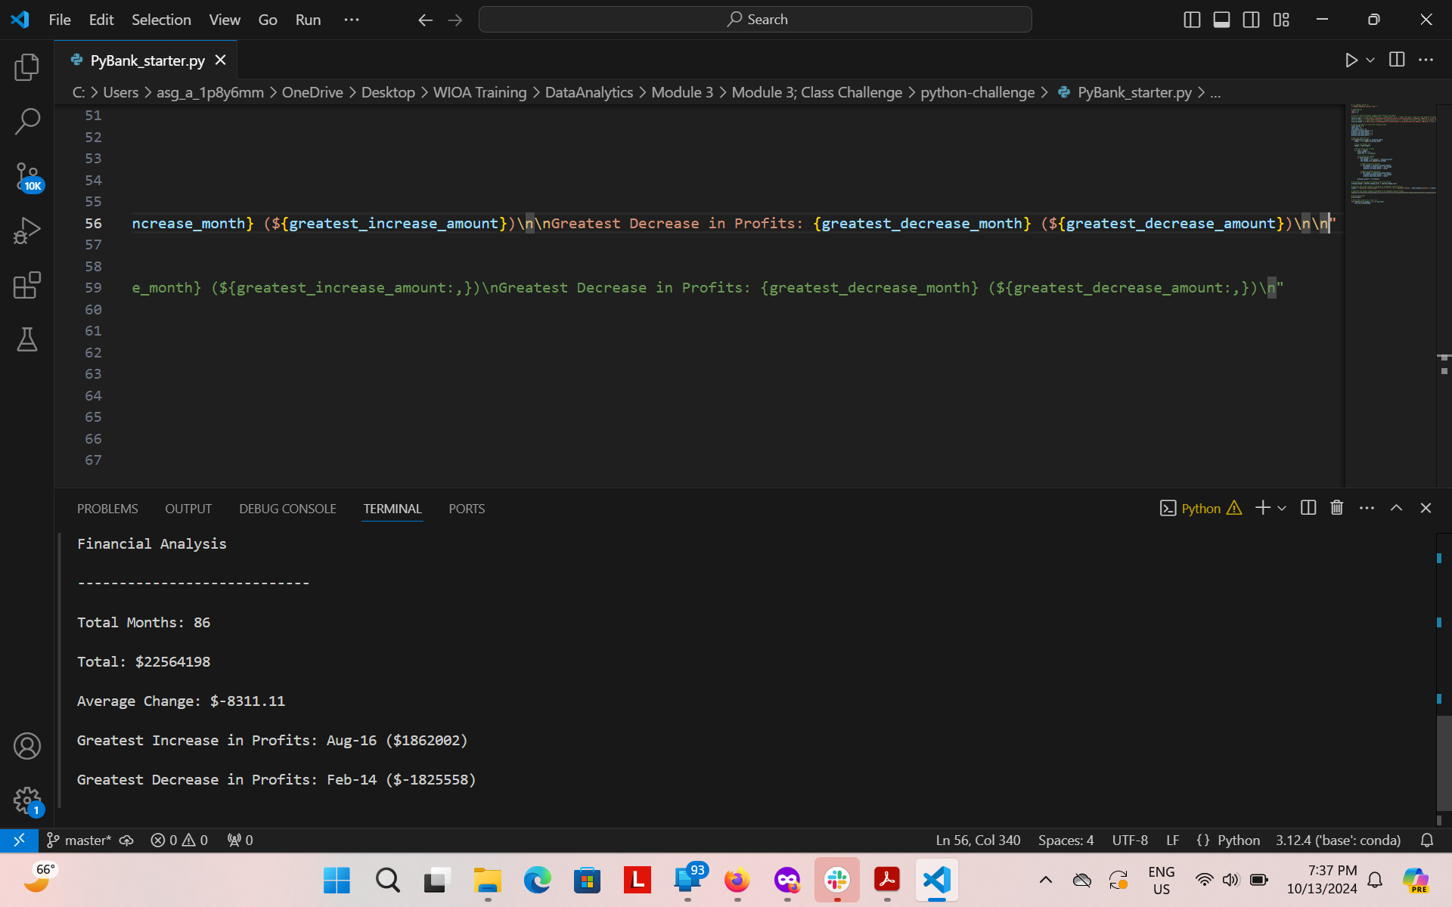

* + Improved output

